Intro/reflection of visual argument:

I wasn’t sure what I wanted to do for my visual argument for a while until I was looking through examples and came across something like this:

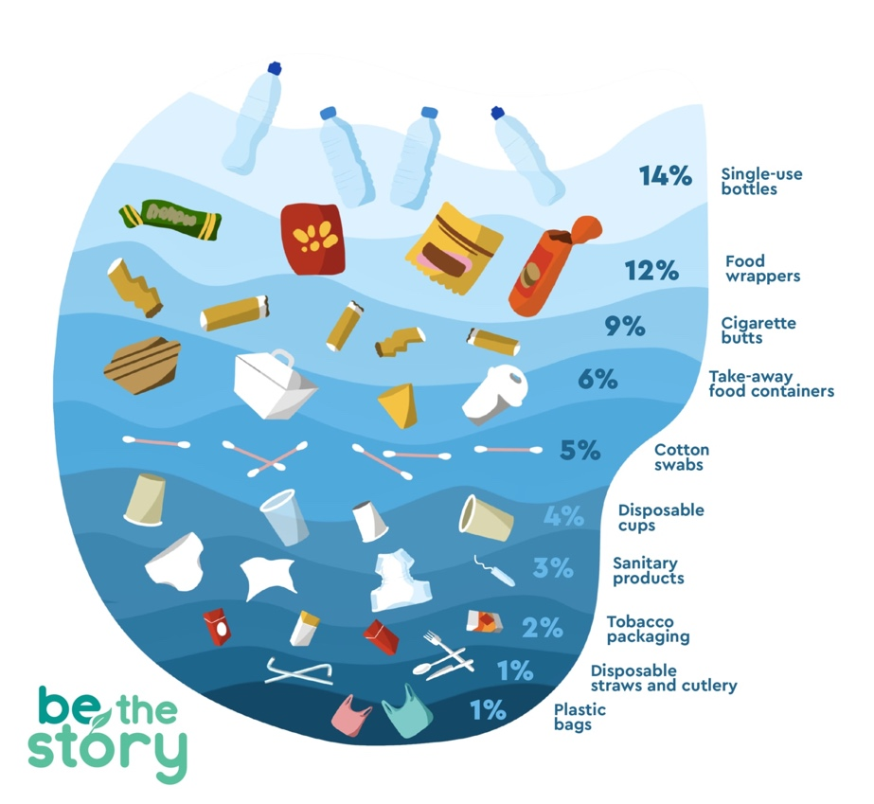

My visual argument was inspired by this image, plastic and just general pollution is continuing to fill out oceans at both our and the marine life’s detriment. I obviously wanted to do something different than this image and thought of those posters you can get that has tons of species or subspecies on it but thought I could use that as an opportunity to show the trash that has been increasing in the waters. The target audience for my visual argument was anyone, as anyone can understand my graphic and it’s not something that is meant to divide people based on opinions. My hope is that anyone who saw my argument would agree or forced to think about something they hadn’t before and what can be done about it.

Once I came up with the idea for this visual argument, it was fairly easy piecing it all together in my mind. I had a bit of trouble with Gimp as it was a bit confusing to use and too complicated for me but luckily my boyfriend was able to help me out as he is very familiar with digital media. My biggest challenge was just navigating all the buttons and layering on Gimp, but the help I had made me less frustrated and got the job done easier.